**P4**

**Introduction**

In this report I am going to explain why different data types are needed in programs and describe the benefits of having a variety of data types available to the programmer.

Different data types are needed in programs, because they are variety of ways they store data. Different types of data types hold different types of variables named below. The main ones are in bold. Every data has a variable that can be stored which includes a set of numbers.

The benefits of having a variety of data types in a programme are that it can store data without wasting it. Everything the data has been saved, nothing is going to be misplaced or corrupted. The performance of the data type can be proceed quickly. Also, it’s flexible and reusable by saving the data. For example, if a music uses data types to save all the music they have used, it would be quicker and efficient when an inspector asks how many CDs you sell.

Data types can be used in:

* 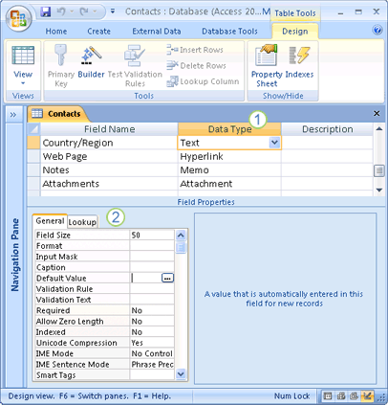Databases
* JavaScript
* [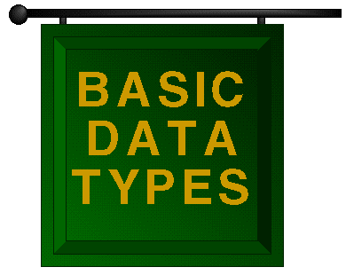](http://www.google.co.uk/url?sa=i&rct=j&q=&esrc=s&frm=1&source=images&cd=&cad=rja&docid=s2bAOqFjxsQV-M&tbnid=J5inLm97SDem-M:&ved=0CAUQjRw&url=http://cgi.csc.liv.ac.uk/~frans/OldLectures/2CS45/basic/basic.html&ei=obQ6Uqz4LLCg7AaKpICADA&bvm=bv.52288139,d.ZGU&psig=AFQjCNEB45s0M62dBkJFS6G1QsJ3RZvwEg&ust=1379665364896286)SQL

[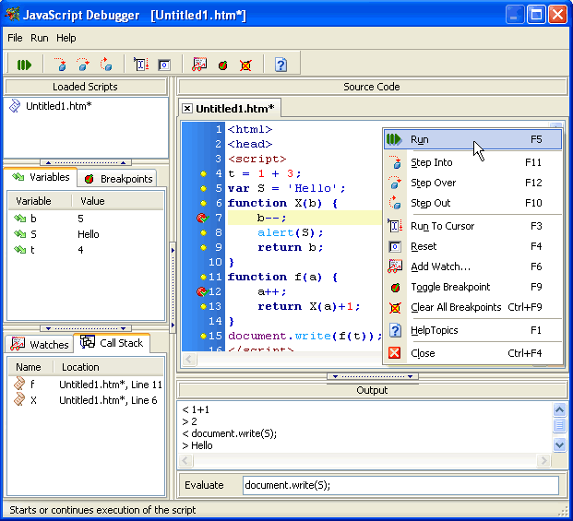](http://www.google.co.uk/url?sa=i&rct=j&q=&esrc=s&frm=1&source=images&cd=&cad=rja&docid=FnZhaOM1Po-rpM&tbnid=ZEnMJbM0sBqqQM:&ved=0CAUQjRw&url=http://www.yaldex.com/JSFactory_Pro.htm&ei=K0w8UrvZDMrB7AaZ4YHQCQ&bvm=bv.52434380,d.ZGU&psig=AFQjCNE1cNGZr7Gs4wtr3z9thgMpT-FjWA&ust=1379769770360515)

[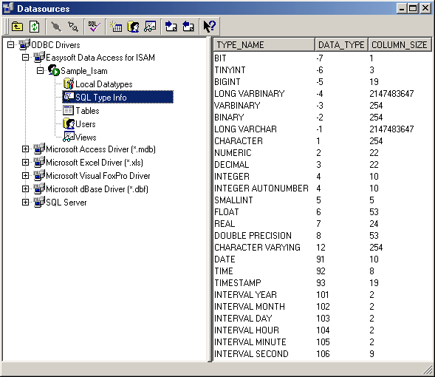](http://www.google.co.uk/url?sa=i&rct=j&q=&esrc=s&frm=1&source=images&cd=&cad=rja&docid=b1LdAqFFz3zdaM&tbnid=G37lQLYAucnw9M:&ved=0CAUQjRw&url=http://www.easysoft.com/products/data_access/administrator/manual/administration.html&ei=5ks8UrPwPK3y7Aas6IDwBg&bvm=bv.52434380,d.ZGU&psig=AFQjCNH_prr2cqK1Z4HTpcARKMtyKddapw&ust=1379769676198117)

The different types of data can be:

* Boolean
* Byte
* Integer
* Long
* Currency
* Single
* Date
* Variant
* String

An example for Boolean data type can be: “utah_won_the_game = true;”

If you want the data type to be Boolean, then you have to write if it’s true or false next to the statement.

“ student.name = 'jim'; % array of characters, or string, part

student.age = 27; % an integer part

student.paid_tuition = false; % a boolean part”

These named are examples of boolean, integera nd string.

<http://www.cs.utah.edu/~germain/PPS/Topics/data_types.html>

I am going to name a few of the following types of data:

|  |  |  |
| --- | --- | --- |
| Data types: | Used for | Example |
| Boolean | Values that can be true or false | True or false |
| Long | Very long large numbers | Approximately up to 2billion and minus |
| Integer | Whole numbers | 15, 78, 89 |
| Date | Date and time | 20/09/2013 |
| Floating-point | Decimals | 5.5, 2.1, 7.9 |
| Variant | Any type of data |  |
| String | Any type of text | Name, Place |
| Double | Large numbers with decimals | Up to 14 significant digits |
| Currency | Decimal numbers with 2 digit after the decimal |  |

*This table above has been copied from the BTEC LEVEL 3 book, but I gave examples of my own.*

|  |  |
| --- | --- |
| <http://cgi.csc.liv.ac.uk/~frans/OldLectures/2CS45/basic/basic.html> | Image |
| BTEC LEVEL 3 ICT BOOK | Book |
| <http://www.cs.utah.edu/~germain/PPS/Topics/data_types.html> | Site |
| <http://www.yaldex.com/imagesJSF/JavaScriptDebugger.gif> | Image |
| <http://www.yaldex.com/JSFactory_Pro.htm> | Image |